**Riverdale’s Royal Court Jester Week**

**Monday Sept 16 – Friday Sept 20**

**Who has the most school spirit?**

**Students and staff can join in the fun**

**all week long with each themed day**

**Throughout the week,**

**one participating student in each class will receive a reward from the PTA.**

**Play along for $0.50 per day or $2.00 for the whole week**

Proceeds support PTA functions for students throughout the year

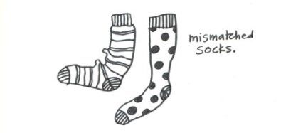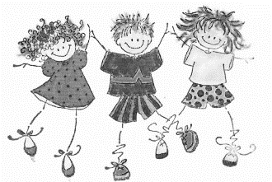

**PJ MONDAY**

Save time in the morning and wear your pajamas to school!

*Stay within dress code including shoes, no slippers please.

**TEAM TUESDAY**

Wear your Favorite Sports Team apparel: Football, Soccer Basketball, Baseball, Volleyball. For whom do you cheer?

**WACKY WEDNESDAY** Wild Hair, mismatched socks, inside out shirts… the wackier the better!

**NEON THURSDAY**

Go Bright, Tropical, Tie-Dye! Bring out your most colorful outfit and let it shine!

**Remember tonight is also family SKATE NIGHT. See you at the Astro rink for an out of this world great time!

**FUN HAT FRIDAY**

Caps, Crowns, Sun-Brimmed, Derby Style, Berets, Top Hats, or Make Your Own.

This is a FASHION Challenge!



La versión en español está disponible en el internet en <https://riverdalees.ocps.net/>

en **Parents** después presione abajo opción **Parent Teacher Association**

 

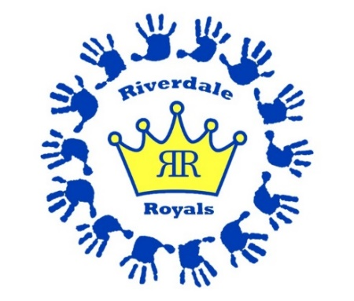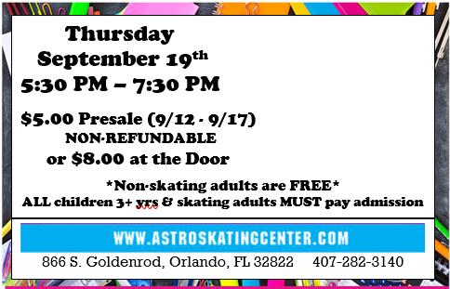

Astro Skate Presale Form

Valid Thursday 9/12 – Tuesday 9/17

after which tickets must be purchased at the event

Student Name _______________________

Grade / Teacher _____________________

Qty# Tickets _______

Amount $__________

*Use of rental skates is included with paid admission*

